

User Guide – Hazardous Waste Treatment Storage, Disposal or Recycling Facility(TSD) Reporting and Payments

Table of Contents

1 Creating an account 3

2 Hazardous Waste TSD forms 3

2.1 Monthly Report 5

2.1.1 Facility Information 5

2.1.2 Monthly Waste Managed 6

2.1.3 Form Review 9

2.1.4 Form Submission 9

2.2 Quarterly Return 12

2.2.1 Facility Information 12

2.2.2 Quarterly Return Detail 12

2.2.3 Payments 12

3 Submission Overview 14

3.1 Submission Statuses 15

3.2 Print or Download a copy 15

3.3 Sharing Access to Forms 15

3.4 Revising a submission 16

3.5 DEQ-Requested Corrections 16

4 Contacts 18

# Creating an account

1. Go to <https://applications.deq.ok.gov/nviro/nform/>
2. Register for a new account. The registration link is on the upper right side of the screen.
   1. Anyone in your organization who will be using these forms should make an account.
   2. Hazardous Waste reporting forms do not require you to complete electronic signatures.

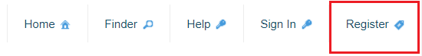

1. After registering, sign into your new account.

# Hazardous Waste TSD forms

To access the Hazardous Waste Compliance Online Reporting Page, place your cursor over “Select Organization.” Scroll down to “Land Protection Division” then click on “Hazardous Waste Compliance” as shown below.

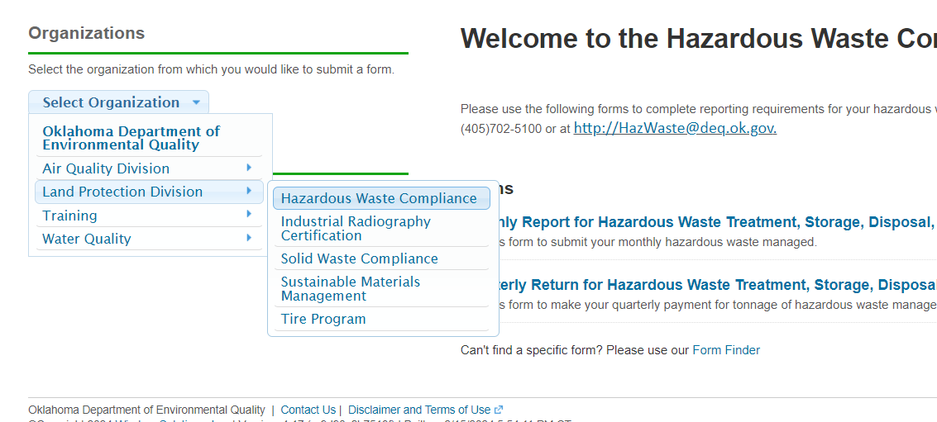

Please use the following forms to complete reporting requirements for your RCRA TSD facility.

* ***Hazardous Waste*** ***Treatment Storage, Disposal or Recycling Facility Monthly Report***  *–* use this form to submit a Monthly Tonnage Report.
* ***Quarterly Return for Hazardous Waste TSD Facilities*** *–* use this form to submit a Quarterly Return and make a quarterly payment. You will not be able to begin a Quarterly Return until all three monthly reports from the reporting quarter have been reviewed by DEQ. You will receive an email once each Monthly Report has been reviewed. Afterwards, you may begin the Quarterly Return.

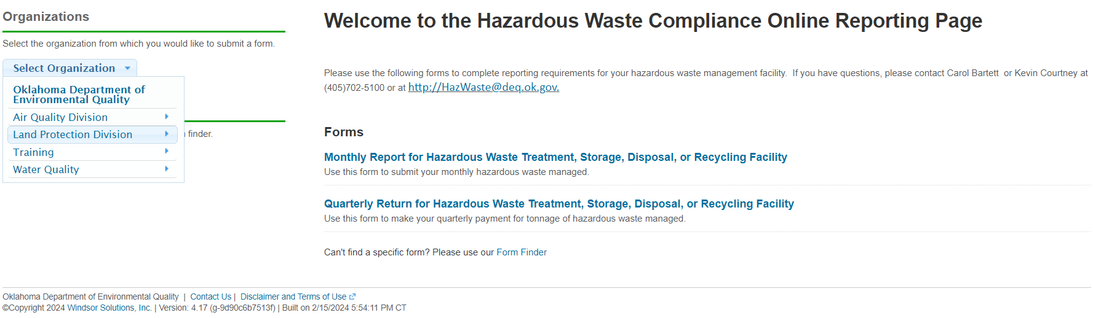

## Monthly Report

After entering your facility’s EPA ID number, you will be able to begin entering your facility’s monthly report.

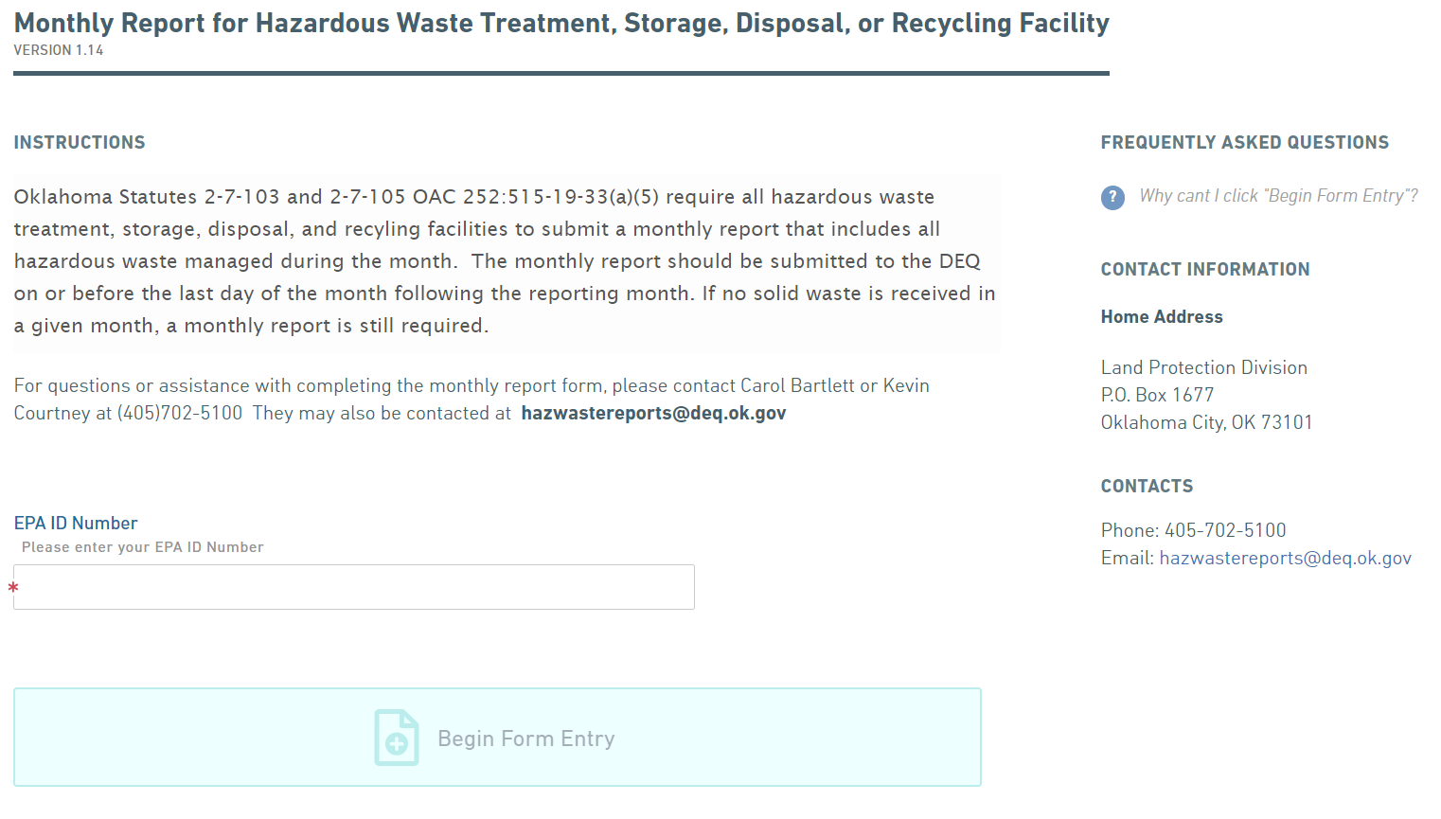

### Facility Information

This information is auto-filled based on your facility’s EPA ID number.

**Point of Contact:** The point of contact is anyone who can answer questions related to the monthly or quarterly report.

If you would like to update the Point of Contact or Alternate Point of Contact, select “Yes” on the question “Would you like to revise the [Alternate] Point of Contact?” and enter the new contact information. After submitting your report, a DEQ member will update the facility’s profile.

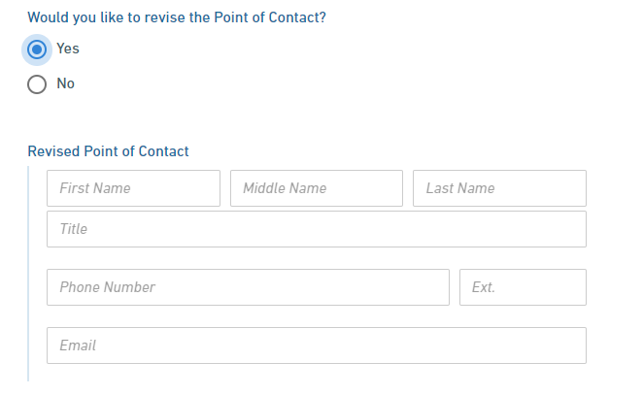

### Monthly Waste Managed

On this page you will select your reporting month from the drop down box and enter your reporting year. Then, you will enter all hazardous waste managed in pounds received for the reporting month, applicable EPA Waste Codes, Generator EPA ID Number, Transporter EPA ID Number, and TSDF Handling Codes for each type of waste managed. You have two options to do this.

**Option 1:** Download an excel sheet as shown below, enter the required information, then upload the document.

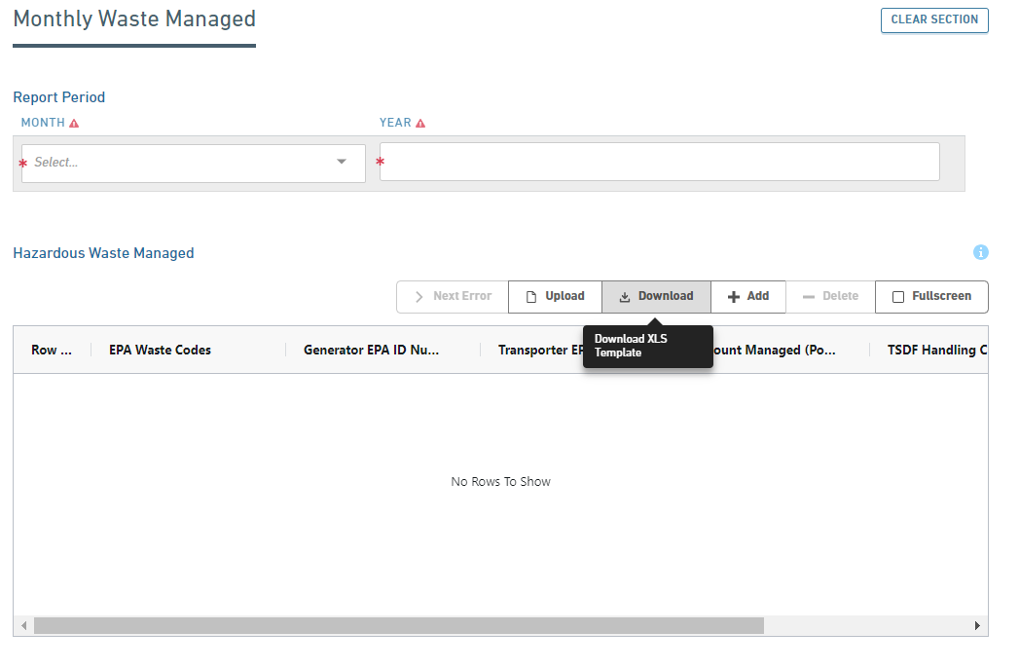

The downloaded excel titled “HazardousWasteManagedMonthlyReport “will pop up in the upper right corner as shown.

Click on this to open the excel sheet, enter the required information, and save the document. Click on upload, choose file, and upload.

Find your saved file and click open.

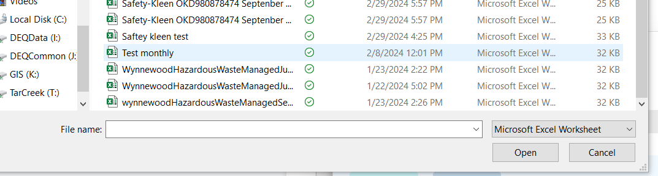

Click on upload to upload the file.

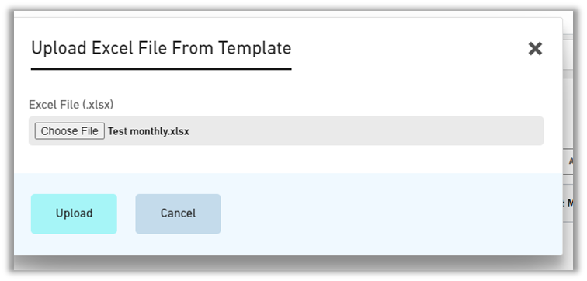

### 

When you click on “upload,” the information from the excel sheet will be populated into the table as shown below.

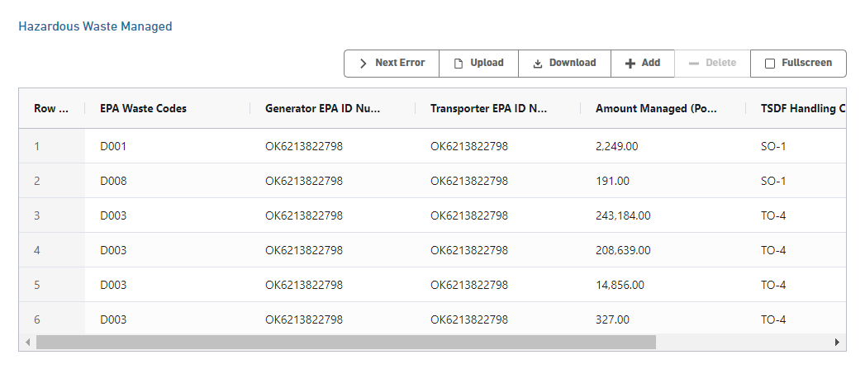

**Option 2:** Click on the table and manually enter the required information. You can use the “Add” button to add rows as needed.

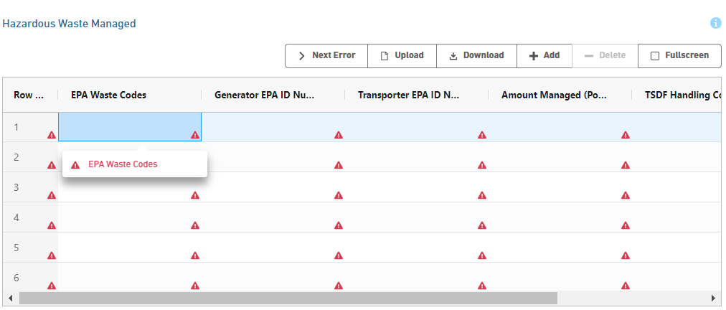

### Form Review

On this page, you will review your form prior to submission. Any incomplete or missing items will be highlighted in red. You will need to return to the previous section(s) to correct any incomplete or missing items.

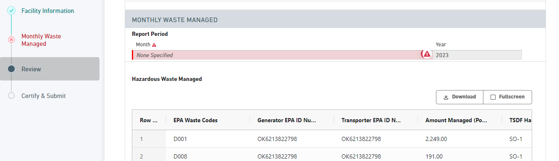

### Form Submission

On the Certify & Submit page, you will submit your form.

You will not be able to submit your form until the form has been fully completed. If the form is incomplete, an error message will appear. Please return to the form and correct any missing or invalid fields.

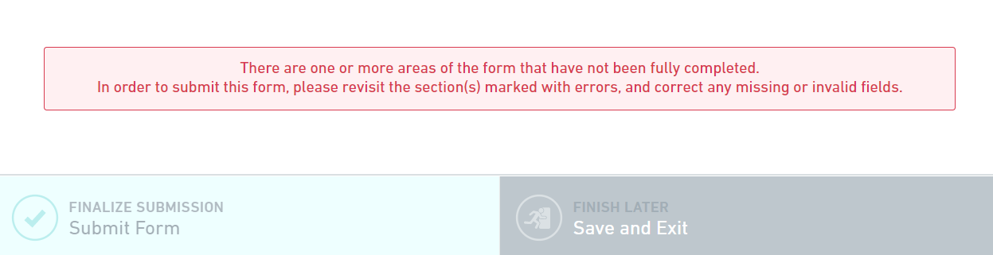

When the form has been fully completed, you will submit your form by clicking the “Finalize Submission” button. Once you have submitted your monthly report, you will see the “Submission Complete” pop-up.

Clicking “View Submission” will take you to the form’s Submission Overview. After submitting a form, it will be in “In Review” status until a DEQ member reviews the form.

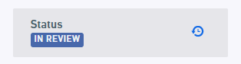

For more information about the **Submission Overview page**, see the “Submission Overview” section below.

After a DEQ member reviews the report, it will be placed in “Completed” status. You will receive an email when the review has been completed for each monthly report. **Please note:** you will not be able to begin a Quarterly Return until you have received an email stating that each monthly report has been marked as Complete.

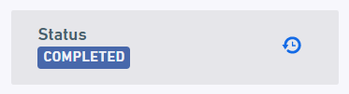

If you would like to **print or** **download a copy of your submission**, see the “Print or Download a Copy” section below.

If you would like to **revise your submission**, see the “Revising a Submission” section below.

## Quarterly Return

Enter your facility’s EPA ID number and click begin form entry.

You will not be able to begin a Quarterly Return until all three monthly reports for the reporting quarter have been reviewed by DEQ. During this time, you may see the error “**Invalid EPA ID Number**.” You will receive an email once each the Monthly Report has been reviewed. Afterwards, you may begin the Quarterly Report.

### Facility Information

The facility information section is the same as in the Monthly Report form.

### Quarterly Return Detail

The Quarterly Return will calculate the hazardous waste management fee that is owed for the quarter. It will be automatically populated based on the Monthly Reports submitted for that quarter. An explanation for how each item can be viewed by hovering over the “i” icon  that appears next to each item.

### Payments

After certifying and submitting your quarterly report, a pop up will appear prompting you to “Pay Online”. Payment options include electronic check or credit card.

Payments made by electronic check will be charged an additional service fee of **$1.00**. Payments made by credit card will be charged an additional service fee of **$2.00 plus 2.25%** of the payment due.

If you wish to **pay later**, you can go to the Submission Overview page for your submission (instructions below). On the right side, you will see the option to “Make Payment.”

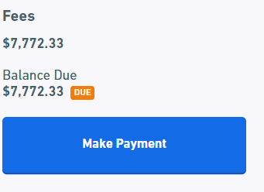

Once DEQ has verified that the payment has been received, DEQ will change the status of your Quarterly Return to “Complete.”

#### Payments by other departments

If another person or department will be completing the payment, the Quarterly Report can be shared with multiple users. To give another user access to the report and payments, see “Sharing Access to Forms” below.

# Submission Overview

The Submission Overview page allows you to view your submission, view its status (Draft, In Review, Complete), make revisions, print or download your submission, or make a payment.

To get to this page, click My Submissions (at the top of the page).



To locate your submission, you can use the Quick Search (top right corner) to search for the form. For example, you can search by Submission ID (ex. HPG-8WNY-BCZ22). You can also click the columns to sort by Name (form name) or the Submission Date.

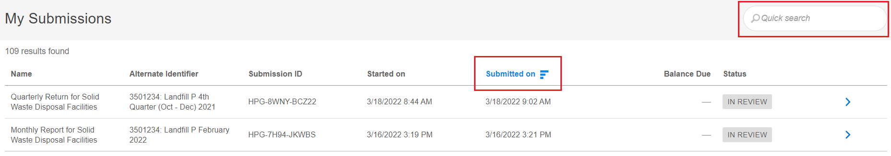

Once you locate the form you wish to view, click the blue arrow on the right.

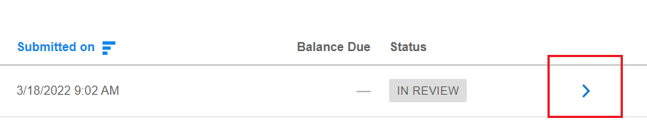

This will take you to the Submission Overview page.

## Submission Statuses

During the creation and submission of a form, it will be in different statuses.

* Draft – your form has not yet been submitted.
* In Review – your form is currently being reviewed by DEQ staff.
* Complete – your form has been reviewed by DEQ staff and has been deemed complete.

## Print or Download a copy

On the right side of the Submission Overview page, there is an option to Print or Download/Export a copy of the submission.

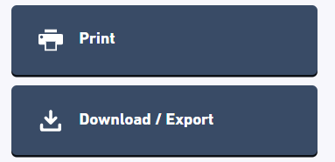

## Sharing Access to Forms

Any form, whether it’s in draft or already submitted, can be shared with multiple users. This is useful if one person will be completing a Quarterly Report and another person will be completing the payment. To share the form, the user must have already created an account.

On the right side of the Submission Overview page, select click “Share with…”.

Next enter the email address of the user you would like to grant access. After clicking “Add” and “Confirm” the user will receive an email with a link to the form.

## Revising a submission

The ability to revise a submission depends on the status of the submission.

* If the status of your submission is “**Draft”**, you have not yet submitted your submission. Click “Continue Editing Draft” to complete your submission.
* If the status of your submission is “**In Review**”, you may click the “Revise Submission” button on the right side of the page. If prompted to update the form, select “Promote.” Please make any edits and submit the form again.
* If the status of your submission is “**Complete**”, please contact a Hazardous Waste team member at [hazwastereports@deq.ok.gov](mailto:hazwastereports@deq.ok.gov) or 405-702-5100.

## DEQ-Requested Corrections

If DEQ staff notice an issue with your submission, you will receive an email letting you know that a correction needs to be made. Your form will not be deemed complete until these revisions are made. To revise and resubmit the form, click the link in the email or open the submission’s Submission Overview.

Under “Notes & Issues” you will see the change(s) that needs to be made. To make these corrections, click “Revise Submission” on the right side of the screen.

Selecting “Revise Submission” will open your submission. On the right side will be a list of any changes that were requested.



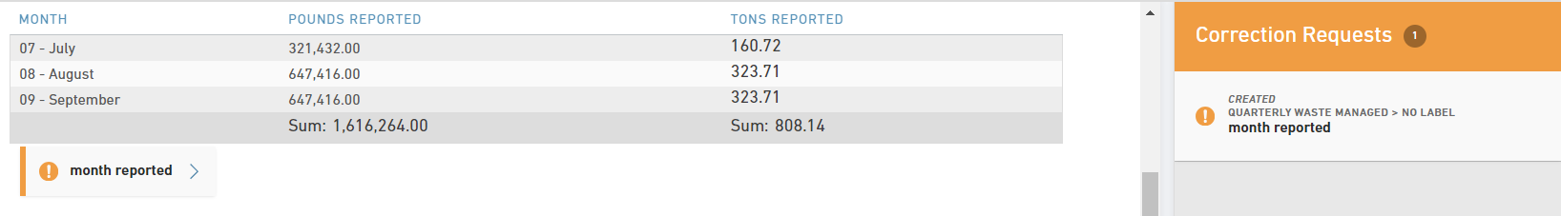

Clicking on each item will open the comments and will take you to each item. After completing each correction, click “Mark Complete” on the right side of the screen. You will not be able to resubmit the form until “Mark Complete” has been selected for each item.

You may also click “Add Comment” on the right side of the screen to add a comment stating if the correction was or wasn’t made. If a correction wasn’t made, please explain why.

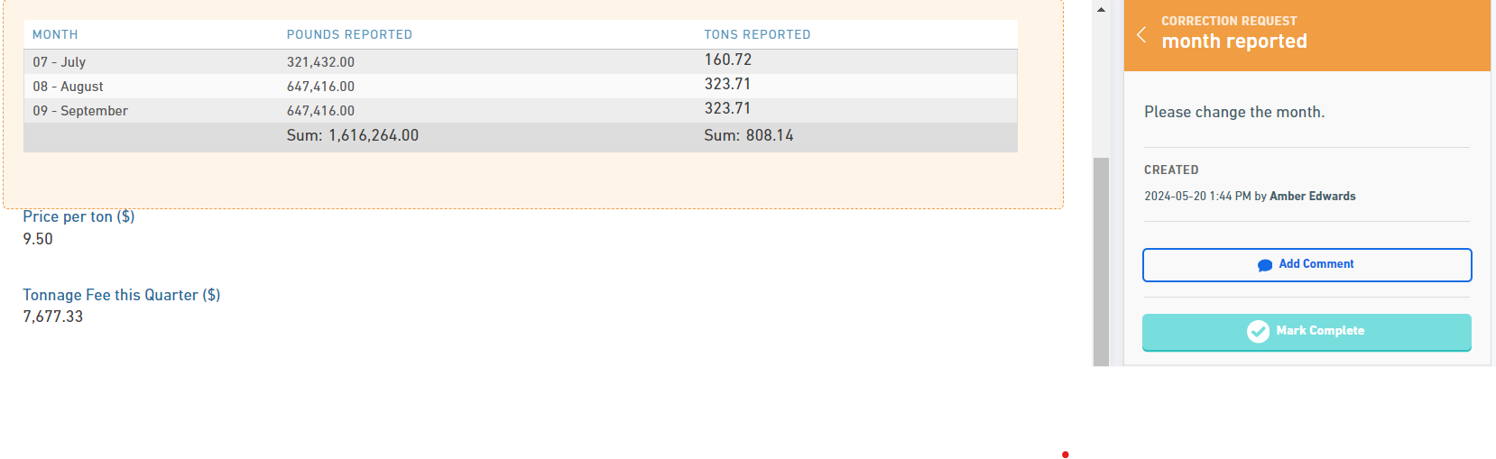

After marking all corrections as complete, the following popup will appear. You may now review and resubmit your form.

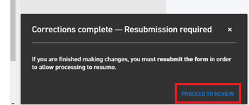

# Contacts

If you have any questions or need assistance, please contact a Carol Bartlett or Kevin Courtney at 405-702-5100 or [hazwastereports@deq.ok.gov](mailto:hazwastereports@deq.ok.gov) .

**Home Address**

Land Protection Division

P.O. Box 1677

Oklahoma City, OK 73101

**Billing Address**

Oklahoma DEQ

Administrative Services Division

P.O. Box 2036

Oklahoma City, Oklahoma 73101